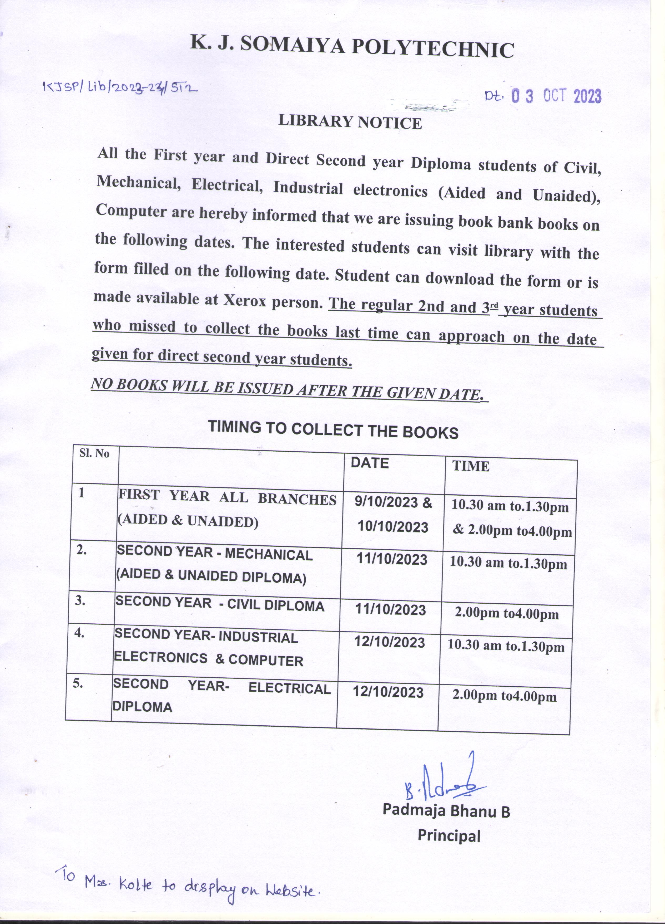
K. J. SOMAIYA POLYTECHNIC, MUMBAI 400 077
BOOK BANK FORM

Date : _________
To,
The Principal
K. J. Somaiya Polytechnic
Mumbai 400 077.

Madam,
I, the undersigned Shri / Kumari ______________________________________________
Request your honor to grant me the following books on loan basis for the current year ______.I am a bonafied student of this polytechnic and I hereby undertake to return all the books lent to me in a good condition, within one week after the examination. In case the books are lost or spoiled by me, in any way, I shall pay the penalty imposed by you. I am prepared to pay nominal rent at 10% of the books price.

(Aided/Unaided) Semester______ Enroll No._____________, ID Number-------------------------------------------------

Permanent Address:
________________________________________________________________________________________________________________________________________________
Mobile Number: ________________

Student’s Signature
Sr. No. | Author | Title | Accession No. | Cost
For Office Use Only
Please accept Rs.__________as 10% of the book price. Receipt No. ________________

Cashier Librarian

